What Is New in Laravel 5.3?
- All the Small Changes (There are a lot) in Laravel 5.3
- Directory (file) changes in Laravel 5.3
- Changes to Routing in Laravel 5.3
- NPM and Yarn in Laravel 5.3
- Cache global helper in Laravel 5.3
- Custom Pagination in Laravel 5.3
- Pivot table toggling instead of sync in Laravel 5.3
- Image dimension validation rules in Laravel 5.3
- Working with JSON and MySQL in Laravel 5.3
- Easier file uploads in Laravel 5.3
- Easier Mail() with Mailable in Laravel 5.3
- Notifications with Notifiable in Laravel 5.3
- Easier Searching with Laravel Scout in Laravel 5.3
- Easier Broadcasting with Laravel Echo in Laravel 5.3

PHP 5.6 -required
php --version

Multiple Migration Paths
Added ability to load migrations from several folders (not just the migrations folder). This allows package developers to load migrations from their vendor files, instead of requiring us to copy migrations into our migrations folder now, developers can tell Laravel about another migrations directory. This means that we can just run php artisan migrate and Laravel will now check all of its known migration directories for new migrations to run. Easy on package developers!
To associate a new migration directory:
$this->loadMigrationsFrom('path/to/migrations/folder');

Migration Step-based Rollback

>php artisna migrate:rollback

Rollback will setback the last migration. Suppose we do 10 migration and we run this command it will undo the last 10th migration and now we have 9 migrations.

>php artisan migrate:reset

It will unmigrate everything, rollback all migrations at once

php artisan migrate:rollback --step=3
Now this will rollback the last three migration steps. Keep in mind that if you run multiple migrations at once, they will count as one step, so reversing that step will reverse potentially multiple migrations. This is why I like to run one migration at a time, or two max if they are related (like users and password_resets on a new Laravel install).

Elixir 6 Released
Elixir is the task manager built for Laravel, on top of Gulp. In fact it runs in a gulpfile.js and makes many gulp tasks easier to run. Shortcuts such as .sass() will compile your sass without any complex setup. This makes working with a task manager easier and faster than ever before.
With Laravel 5.3, comes the release of Elixir 6 bundled in. The main improvements with Elixir 6 is support for Webpack.js and Rollup.js as a module bundlers. In addition, the user interface and user output of Elixir has been greatly improved.
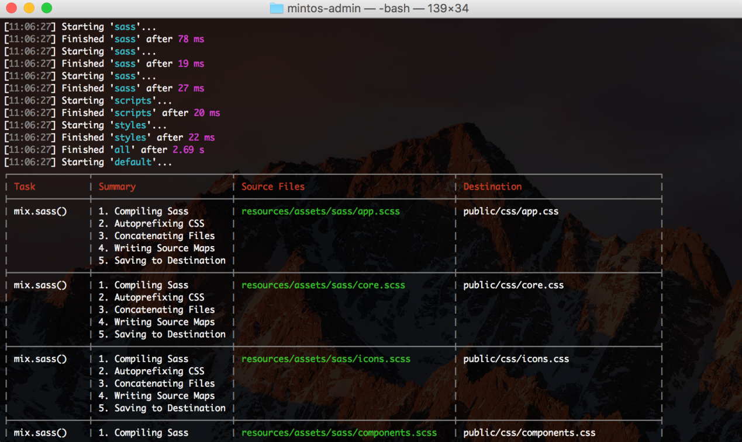
This is the new layout of Elixir 6. It makes it super easy to see what is happening.

New Layouts

Installing the early release of laravel

>laravel new --dev your_project_name

When you run php artisan make:auth the new views generated are cleaner.
Default login, register, forget my password are created.

Dependencies Pulled from Package.json
As minor as it might be, it is worth noting that dependencies like Vue.js (more on this later), jQuery, and Bootstrap are no longer pulled in from your template files, but instead through your package.json file. As you can see here, all of our dependencies are located by default in this package.json file located in your application root.
These dependencies are pulled in through NPM, and then extracted to assets/js/bootstrap.js where you can set these things up and load them into your views or template files.
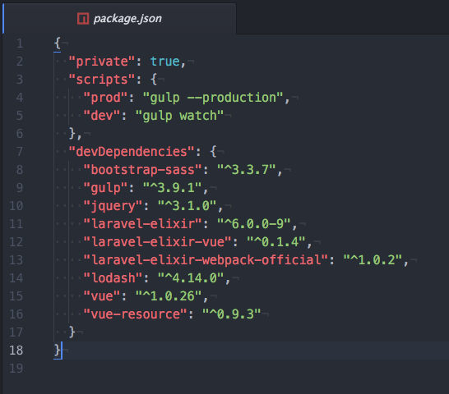

Controller Changes
If you are writing packages for Laravel and are creating a controller that doesn’t require all of Illuminate routing features, then you can now omit the extends controller on your function. You can generate data right inside the controller for use in your package without all of that overhead. Nice little change.
This will not effect most of us because most of our Controllers need Illuminate\Routing so you will still need to extend controller for most of our general use controllers.
Controllers also can have a new __invoke() method for controllers that only have one method. Sometimes when writing complex controller methods you might find it easier to extract an overly complex method to its own controller. Now you can put that method into the __invoke() method and call that controller from a routes file with just the controller and not the @ sign afterwards. Calling just your controller and no method will initiate the __invoke() method. Cool stuff!
Inside controller-
public function __invoke()
{
//code goes here.
}
Route file -
Route::get(‘/home’, ‘ControllerName’);

Inline Custom Artisan Commands

Need to build a quick artisan command? Well now in Laravel 5.3 it is easier than ever before. You can now build custom artisan commands (these are the php artisan ____ commands that we use in the terminal) right inline in our Kernel.php file.

The command will pull in any parameters you pass it in the terminal and you can define what you want it to do right from within a closure.
An example of a quick command would be like this:
protected function commands()
{
$this->command('im {name}', function($name) {
$this->info('Good to meet you '.$name);
});
This will now output in the terminal like this.
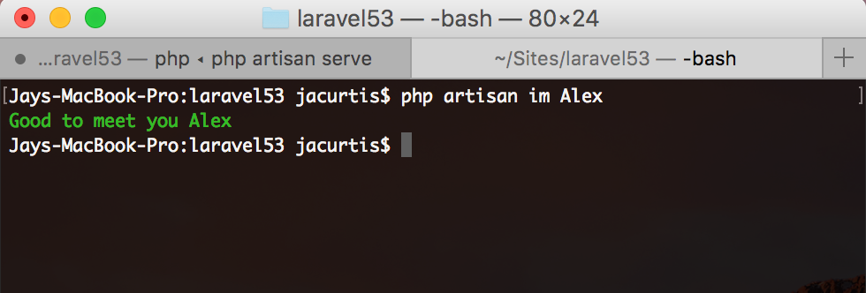
These commands will also show up in your Artisan help file. So you can run php artisan help and you will see our new “im” command. If you want to write a better description for this command you can also append ->describe('Human readable text here'); to your closure as well.
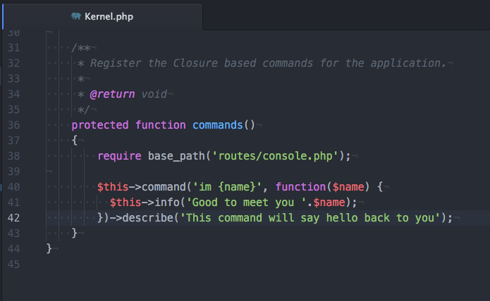
With this describe command now in place, we can run php artisan list and see in our help file now, in alphabetical order is our im command (we really should have given this a better name).

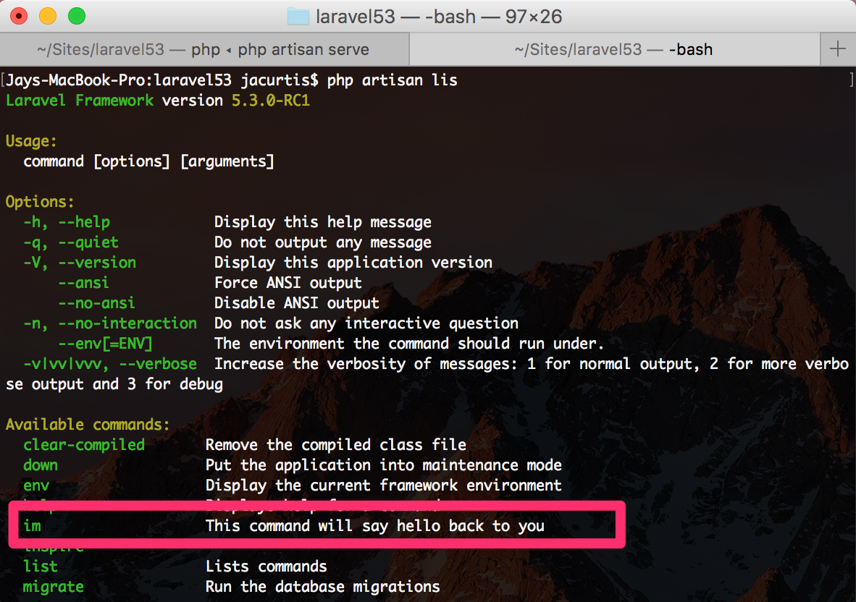

Running Queue Workers
If you are running any queue workers, then the good news is that a lot has changed under the hood of Laravel to make working with Queue workers so much better. Queue workers felt like a beta feature in Laravel 5, so Taylor Otwell now says that the entire underlying framework for Queue workers has been overhauled. This will make them more reliable in general, but there are two minor API changes that you might want to know about.
First is that now when you run php artisan queue:work it will by default run the ongoing daemon. This is equivalent to the old command php artisan queue:work --daemon, so you no longer need to run that command. Just run the base command to get the daemon (which is what you usually want anyway. If you do in fact want to run the queue workers only one time, then you can pass in the flag --once in the same way you passed the daemon flag before. This will run it just one time. In my opinion this was a good change, because I feel like the daemon was a more common use of the queue workers anyway so you might as well make it the default.
Furthermore, if you have ever had a queue worker get stuck, preventing jobs from running then you will jump for joy with the new timeout command. In your queue worker command now you can issue a time (in seconds) that you want the queue workers just give up and continue working on the next job. You will get a log entry for the error.
The really nice thing about killing queue workers is that the jobs can continue to run. So you are freeing the worker up to do more jobs, but the jobs can continue to finish in the background.

FirstOrCreate() Accepts Custom Parameters
There isn’t much to say with this one other than you can do it and it will be nice.
Basically when calling firstOrCreate() you can now pass in other parameters to save to the new user if you end up needing to create it.
User::firstOrCreate(['github_id', $githubUser->id], ['avatar' => $githubUser->avatar]);
You can read the pull request here, and as you see, I pulled this example straight from the pull request. In this example we see that we let a user login with oAuth via GitHub. We don’t know if this is a new user or not, so we find a user by this github_id and if they exist then we grab them, if they do not exist, then we create a new user with this github_id and also pass in their github avatar while creating the user. Slick!

Routing File Changes
web.php includes all the web middleware.
api.php includes all the api middleware, the API prefix, the throttling.

How do we know that? How do you maybe change that? Or How do you add some of that functionality to a new file if you want to make a new file?
app>provider>RouteServiceProvider.php
Inside this file we can find mapWebRoutes() and mapApiRoutes()

Where is the middleware coming form? Like the web middleware or api middleware.
app>Http>kernel.php
Inside this file we can find our middleware gourps eg. web middlware group

'throttle:60,1', - this means that 60 request every 1 minute ie,
1 request/ second

Vendor Folder: It contains all the source code for all the packages we got including all of their dependencies. Composer is the one which maintain those.
Composer figures out which package we want based on the composer.json file
Just like composer.json file wich tell all of the packages we want in our PHP project we have the same one for our java script callad package.json
Node modules they are all javascript packages

gulp is an open-source JavaScript toolkit by Fractal Innovations and the open source community at GitHub, used as a streaming build system in front-end web development.
Yarn is the package manager built by facebook. It works similar to NPM package manager, but it is more fast, reliable and secure dependency manager.

Laravel 5.4 New Features - Part 1: All the Small Changes Overview

resources>assets>js>app.js
Gulp is no longer used, Laravel elixir no longer uses gulp as its compiler and now uses web pack primarly and we use it all through npm.
We are using NPM to run our processing our JavaScript, ass, less files
>npm install

Resources>js>app.js
-its our main compiled js file
Resources>js>bootstrap.js
window._ = require('lodash');
Lodash is a bunch of JavaScript helper functions. It gives JavaScript a lot of helper functions that PHP has.
Axios is a ajax HTTP library
We are also getting jquery, bootstrap javascript functions, vue and axios
Change Logs for Relese 5.4.x
@push() will add content to the stack starting from the view being rendered, @prepend will add content to the beginning of the stack.
@stack() will display the $prepends in reverse order + the $pushes in normal order.
// layout.blade

@stack('letters')

// master.blade

@extends('layout')

@push('letters', 'A')

@prepend('letters', 'B')

// welcome.blade

@extends('master')

@push('letters', 'C')

@prepend('letters', 'D')
Having View::make('welcome'), the output will be:
BDCA

Laravel Mix-

In Laravel 5.4 we have gotten rid of Gulp and Laravel Elixir and are now using Laravel Mix, which is built on top of Webpack. This gives us great customizability and flexibility.

/webpack.mix.js
-------------------------------------------------------------------------------------------------------------
const mix = require('laravel-mix');

//We are pulling laravel-mix

mix.js('resources/js/app.js', 'public/js')
.sass('resources/sass/app.scss', 'public/css');

//configuring laravel-mix to do whatever we want it to do.
Compile javaScript with .js command (where the refrence file is, where we want to compile the new version into)
.sass directive(path to scss file, path where the file should be compiled as css)
--------------------------------------------------------------------------------------------------------------

/package.json

Fluent Routing - Laravel 5.4 New Features
In Laravel 5.4 we can now make and modify our routes using an all new, easier to use syntax! We call this Fluent Routing. Instead of using tons of embedded arrays in our routes file, we can now use a more object oriented approach. Just combine whichever functions you need, to get the job done. You can use: - prefix() - middleware() - name() - get() - post() - put() - delete() - options() - patch() - group() Use them however you want and in any order. This allows you to better organize your routes file appropriately.
Old way :-
Route::get(‘/home’, [‘uses’ => ‘HomeController@index’, ‘as’ => ‘home’, ‘middleware’ => ‘auth’]);
New way:-
Route::get(‘/home’, ‘HomeController@index’)->name(‘home’)->middleware(‘auth’);
Or
Route::name(‘home’)->middleware(‘auth’)->get(’/home’, ‘HomeController@index’);
Grouping Routes together

Route::prefix(‘users’)->middleware(‘auth’, ‘anothermiddleware’)->group(‘users’, function() {
Route::name(‘home’)->get(’/home’, ‘HomeController@index’);
Route::name(‘home’)->get(’/home’, ‘HomeController@index’);
Route::name(‘home’)->get(’/home’, ‘HomeController@index’);
//localhost/users/home
});

New Middlewares
In Laravel 5.4 we have two new middlewares available on every HTTP request. This is useful for sanitizing input data with minimal efforts. The two new middlewares are:
- Trim Empty Spaces from Strings
- Convert empty strings to NULL
These really help if you're a fan of using Mass Assignment to store your form data into a database. This means you can more safely store data without needing extra processing, like what might have been needed in the past.

